**MATERIAL 1**

**Video: Dystopia**

**https://ed.ted.com/lessons/how-to-recognize-a-dystopia-alex-gendler**

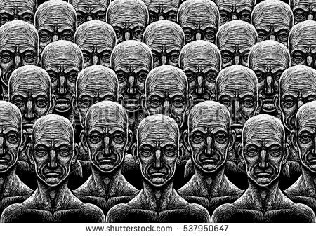

**Task**

Watch the video carefully and find out:

|  |
| --- |
| ***1 where the word Utopia comes from and what it means*** |
| **The word Utopia comes from Greek and means “no place”. It was used by Sir Thomas More for his 516 book Utopia. Utopia describes** **an imagined place or state of things in which everything is perfect.** |
| ***2 what the difference between utopia and dystopia is*** |
| **A dystopia gives the impression that it was originally designed as a utopia. In other words, it is a utopia that has gone wrong.**  **So an Utopia describes a state in which everything is perfect, while the dystopia describes a Utopia in which everything has gone wrong.** |
| ***3 which political, technological, … developments have been dealt with in dystopian novels in the course of time:*** |
| * J. Swift (17th): * H.G.Wells, Jack London (19th): * A. Huxley, Y. Zamiatin, O. Wells (20th) |
| ***4 what dystopias are about in our days and name some examples*** |
| I think you could call a lot of our todays states as a dystopia. I would call countries a dystopia, if they have a problem with police brutality or total monitoring of the population and I think that’s the case in a lot of countries. I would also describe countries as a dystopia if there`s war. For example, Syria. There are a lot of different countries fighting against each other at the expense of the population. |

**And over to you:**

**Writing exercises (to be done AFTER you have read the articles on the differences between utopia and dystopia)**

***5 What would a utopian world/society be like in your view? Offer a short description.***

***6 Drawing on the many bad news we are faced with every day, which dystopian reality might future generations be cast into?***

**Summary:**

The name Utopia comes from Thomas **Moore’s** Utopia, written in 1516.

Modern scientific and political progress seemed to make it possible but in reality it lead to war, famine and oppression.

Artists started to question the idea of utopia and created the genre of dystopia.

**Gulliver’s Travel**: portrays fictional societies modelled on contemporary society. It depicts trends in Swift’s society taken to the extremes showing its flaws as they lose connection with the reality.

The Industrial Revolution offered new material for dystopian novels. Industrial technology and progress seemed to promise to free the labourer but it imprisoned them in slums and factories instead.

**H.G. Wells Time Machine** imagined upper class and works to evolve into different species.

**Jack London, The Iron Heels** imagined an oligarchy ruling over impoverished masses.

20th brought new hopes and fear with medical advances that transcended biological limits, mass media that allowed instant communication between leaders and the public.

**A.Huxley, Brave new World**: citizens are genetically engineered and conditioned to perform their social roles, propaganda and drugs keep the people happy at the cost of some crucial human elements.

Real life dystopias: world wars, totalitarian regimes of 20th century.

**Yevgeny Zamiatin, We**: describes a society where free will and individuality is eliminated

**G. Orwell, Animal Farm**; 1984: mocking the communist regime and criticising totalitarianism, media and language.

**After WWII** atomic energy, space travel and artificial intelligence gave new ideas to modern utopian science fiction in films, games and comics: robots who turn against, deadly mass entertainment on TV, people toiling in space colonies, cities plagued by overpopulation, crime and left without resources, nuclear war, societies that have lot their human rights.

Today’s dystopian novels deal with social inequalities, climate change, governmental power, epidemics.

But what all these dystopian novels are about: dystopian tales about the idea that humanity can be modelled into an ideal shape.